SIMATS ENGINEERING (SAVEETHA SCHOOL OF ENGINEERING)
Department of Computer Science and Engineering
ASSESSMENT TOOL 2 – MODEL COMPARISON PRESENTATION (BERT VS GPT VS T5VS LLAMA)
Name: G Sumanth
Reg.No: 192472124
Course Code: CSA65
Course Name: Generative AI

QUESTION 1
Compare the architectures of BERT, GPT, T5, and LLaMA. Explain the major architectural differences and identify the type of NLP tasks each architecture is best suited for.

1. Introduction
BERT, GPT, T5, and LLaMA are Transformer-based language models, but they use different architectural designs and training approaches. BERT is an encoder-only model, GPT is decoder-only, T5 is encoder-decoder, and LLaMA is decoder-only. These differences determine whether a model is mainly optimized for language understanding, language generation, or sequence-to-sequence transformation.

2. BERT Architecture
BERT stands for Bidirectional Encoder Representations from Transformers. It uses only the Transformer encoder. Its main characteristic is bidirectional contextual understanding, where the representation of a word can use information from both sides of the input.
During pre-training, BERT uses Masked Language Modeling. Some input tokens are masked and the model learns to predict the missing tokens.
Processing flow: Input Text → Tokenization → Transformer Encoder → Contextual Representation → Classification or Other NLP Task
BERT is best suited for sentiment analysis, text classification, named entity recognition, extractive question answering, semantic similarity, and information extraction.

3. GPT Architecture
GPT uses a decoder-only Transformer architecture. It generates text autoregressively by predicting the next token from the previously available tokens. Its causal attention prevents a token from using future tokens during prediction.
Processing flow: Prompt → Tokenization → Causal Self-Attention → Next Token Prediction → Generated Text
GPT is well suited for text generation, chatbots, conversational AI, question answering, code generation, content generation, and few-shot or prompt-based tasks.

4. T5 Architecture
T5 stands for Text-To-Text Transfer Transformer. It uses both an encoder and a decoder. The major idea is to represent different NLP problems as text-to-text problems.
For example, a translation task can be expressed as an instruction followed by input text, with the translated sentence produced as the output.
Processing flow: Input Text → Encoder → Context Representation → Decoder → Output Text
T5 is especially suitable for machine translation, text summarization, question answering, text generation, and classification expressed in text form.

5. LLaMA Architecture
LLaMA is a decoder-only Transformer-based language model. Like other autoregressive decoder models, it predicts the next token based on the preceding context.
Processing flow: Prompt → Tokenization → Decoder Layers → Next Token Prediction → Generated Response
LLaMA is suitable for chatbots, text generation, question answering, coding applications, summarization, and customized generative AI applications.

6. Major Architectural Differences
The main difference is the direction and purpose of information processing. BERT uses an encoder-only architecture and focuses on understanding the complete input context. GPT and LLaMA use decoder-only architectures and generate output progressively using causal attention. T5 combines an encoder and decoder, making it suitable for transforming one sequence of text into another.
In simple form: BERT → Understanding; GPT → Generation; T5 → Text-to-Text Transformation; LLaMA → General-Purpose Generation.

7. Application Mapping
For sentiment analysis and named entity recognition, BERT is a strong choice because these tasks depend heavily on contextual language understanding.
For free-form text generation, chatbots, and conversational systems, GPT and LLaMA are suitable because they are decoder-based generative models.
For translation and many sequence-to-sequence tasks, T5 is appropriate because its encoder-decoder architecture is designed to map an input sequence to an output sequence.
For extractive question answering, BERT is suitable, while generative question answering can be handled by GPT, T5, or LLaMA.

8. Strengths and Limitations
BERT's major strength is accurate contextual language understanding and its suitability for fine-tuned classification tasks. Its main limitation is that it is not naturally designed for free-form text generation.
GPT's major strength is flexible language generation and prompt-based task handling. A limitation is that generated responses can contain incorrect information and large models can require substantial computational resources.
T5's major strength is its unified text-to-text framework, allowing many NLP tasks to be handled through the same general formulation. Its encoder-decoder design can require more computation than a simple encoder-only classifier.
LLaMA provides strong generative capability and can be adapted for customized applications. As with other generative models, its outputs may sometimes be inaccurate or unsupported.

9. Conclusion
There is no single model that is best for every NLP task. BERT is most appropriate when language understanding and classification are the main requirements. GPT is highly suitable for general-purpose text generation and conversational applications. T5 is highly suitable for sequence-to-sequence tasks such as translation and summarization. LLaMA is suitable for general-purpose generative AI and customizable language applications. Therefore, the architecture should be selected according to the application requirement.
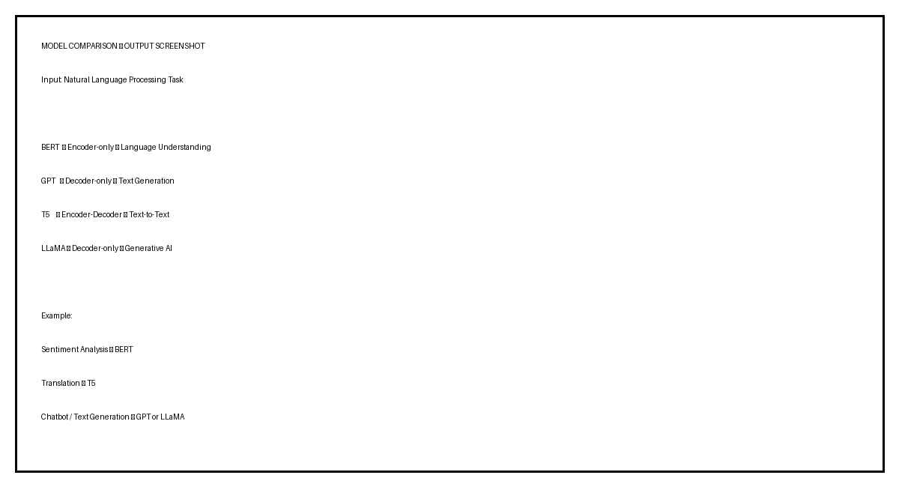
Figure 1: Output screenshot – Architecture comparison

QUESTION 17
Compare BERT, GPT, T5, and LLaMA for sentiment analysis and other text classification tasks. Justify the best model for the application.

1. Introduction
Sentiment analysis determines whether a text expresses a positive, negative, or neutral opinion. Text classification also includes spam detection, topic classification, intent detection, and emotion classification. BERT, GPT, T5, and LLaMA can all perform classification, but their architectures make them suitable in different ways.

2. BERT for Sentiment Analysis
BERT is particularly suitable for sentiment analysis because its encoder creates contextual representations of the input. A typical system is: Review → Tokenization → BERT Encoder → Classification Layer → Sentiment.
For example, the review 'The product quality is excellent' can be classified as Positive after fine-tuning BERT on labeled sentiment data.
Advantages include strong contextual understanding, effective fine-tuning, direct support for classification, and suitability for domain-specific datasets.

3. GPT for Sentiment Analysis
GPT can perform sentiment classification using natural-language prompts. A prompt can instruct the model to classify a review as Positive, Negative, or Neutral.
GPT is useful when sentiment analysis must be combined with explanation, summarization, conversation, or other generated outputs. It can also support zero-shot and few-shot classification.
For a simple high-volume classification system, however, a specialized encoder model can be more direct and computationally practical.

4. T5 for Sentiment Analysis
T5 treats classification as a text-to-text task. For example, the input can be 'sentiment: The product is excellent' and the expected text output can be 'positive'.
T5 provides a unified framework for classification, translation, summarization, and other text-to-text tasks. For a simple three-class sentiment problem, an encoder-only classifier may be more direct.

5. LLaMA for Sentiment Analysis
LLaMA can perform sentiment classification through prompting or fine-tuning. It is particularly useful when sentiment analysis is part of a larger generative AI workflow.
Example workflow: Customer Review → LLaMA → Sentiment + Explanation + Recommendation.
This makes LLaMA useful when the system must not only classify the review but also generate a natural-language explanation or follow-up response.

6. Real-World Application Mapping
For product sentiment classification, BERT is a strong choice because of its contextual classification capability.
For spam detection and customer intent detection, BERT is also suitable because these are primarily language-understanding and classification problems.
For few-shot sentiment classification, GPT can be useful because it can follow prompts without requiring a separate classifier for every task.
For sentiment combined with summarization, T5 is useful because of its text-to-text formulation.
For customer-support systems and review analysis with explanations, GPT or LLaMA can be useful because classification can be combined with text generation.

7. Case Study: E-Commerce Review Analysis
Consider an e-commerce company receiving thousands of customer reviews. Example review: 'The phone has a great camera, but the battery life is poor.'
Using BERT, the review can be sent to an encoder followed by a classification layer to obtain the sentiment label.
Using GPT, a prompt can request the sentiment and an explanation.
Using T5, the review can be formatted as a text-to-text classification task.
Using LLaMA, the system can produce the sentiment together with an explanation and a recommendation.
If the company mainly needs reliable and efficient sentiment labels, BERT is the most appropriate choice. If it needs a larger generative customer-support workflow, GPT or LLaMA may be preferable.

8. Best Model for Sentiment Analysis
Recommended model: BERT.
For a dedicated sentiment-analysis and text-classification system, BERT is the strongest choice among the four because its encoder-only architecture is designed primarily for language understanding. It can be fine-tuned for a classification task and can directly use a classification head.
BERT is therefore recommended when the output is mainly a class label such as Positive, Negative, Neutral, Spam, Not Spam, or a specific topic.
GPT or LLaMA becomes more attractive when classification must be combined with explanation, conversation, summarization, or other generative tasks.

9. Final Conclusion
BERT is best for dedicated classification. GPT is best when flexible prompt-based classification is combined with generation. T5 is suitable for classification within a text-to-text framework. LLaMA is suitable when classification is combined with broader generative AI.
Therefore, for conventional sentiment analysis, BERT is the recommended model. The final selection should depend on the application's accuracy requirements, computational resources, need for generation, and customization requirements.
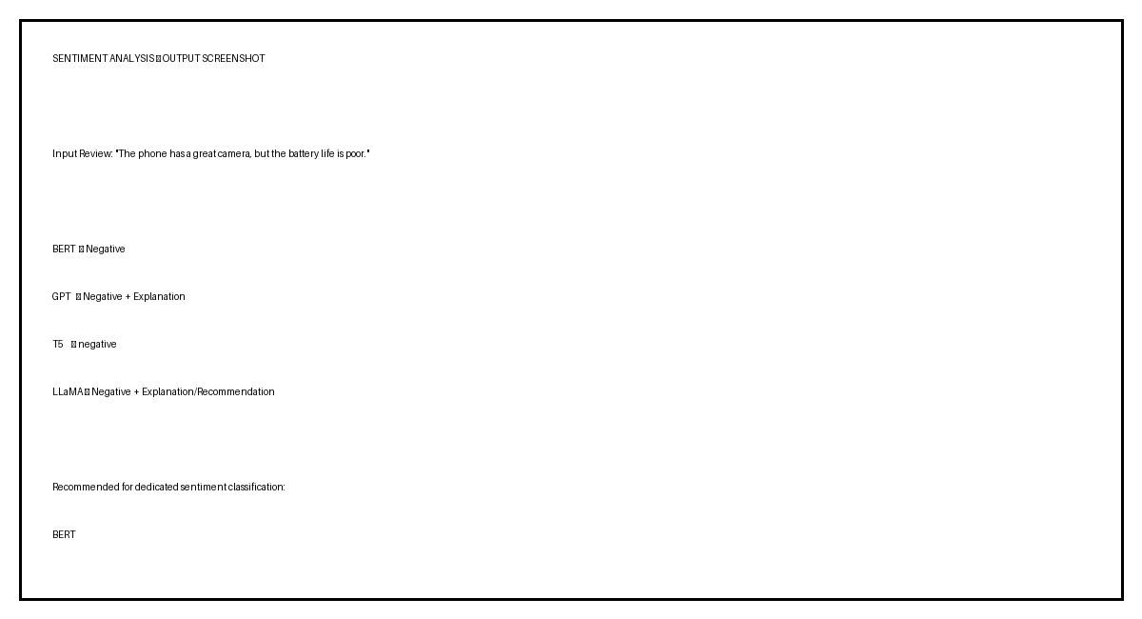
Figure 2: Output screenshot – Sentiment classification

References
Devlin, J., Chang, M.-W., Lee, K., & Toutanova, K. (2018). BERT: Pre-training of Deep Bidirectional Transformers for Language Understanding.
Brown, T. B., et al. (2020). Language Models are Few-Shot Learners.
Raffel, C., et al. (2020). Exploring the Limits of Transfer Learning with a Unified Text-to-Text Transformer.
Touvron, H., et al. (2023). LLaMA: Open and Efficient Foundation Language Models.

